**8. Develop a system using UML for Software Personnel Management System. It should be used to**

**process the details of a person who works in a software company. The details are to be stored in**

**the central management system for cross-checking the person’s details**

**USE CASE DIAGRAM**

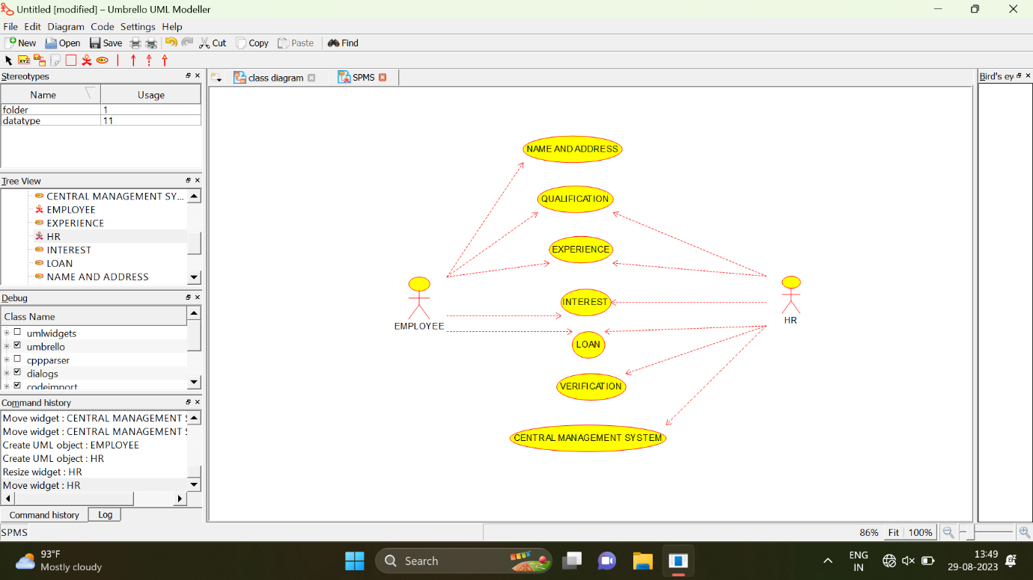

**ACTIVITY DIAGRAM**

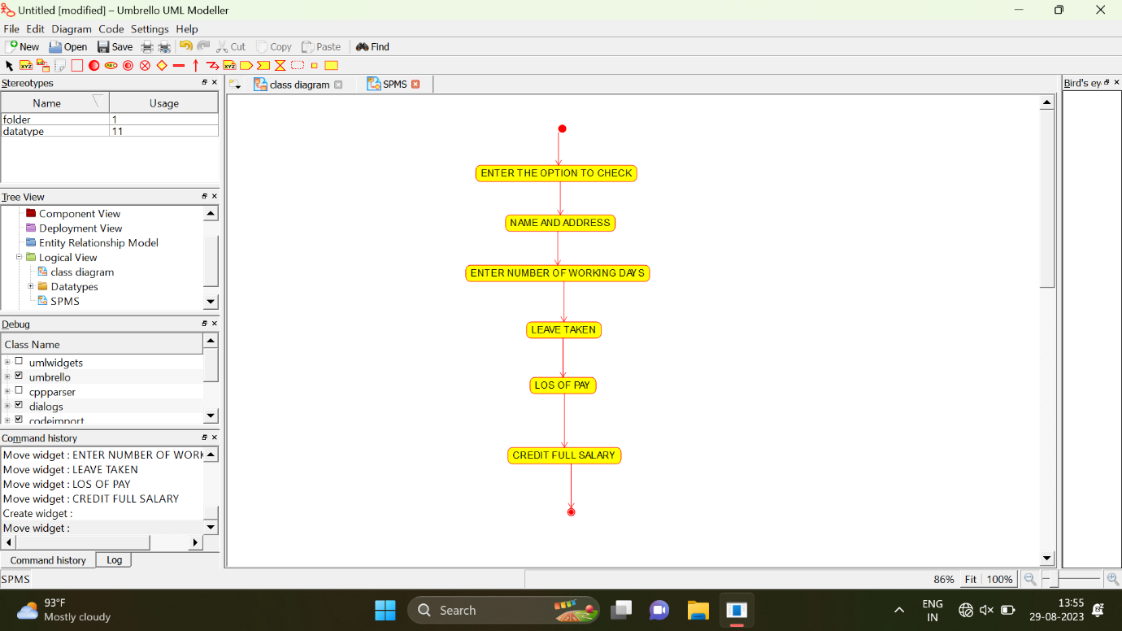

**SEQUENCE DIAGRAM**

